**Name: Omkar pralhad Gharat**

**Enrollment No.: 2101950**

**Cloud Computing Practical-3**

**\*\*\*\*\*\*\*\*\*\*\*\*\*\*\*\*\*\*\*\*\*\*\*\*\*\*\*\*\*\*\*\*\*\*\*\*\*\*\*\*\*\*\*\*\*\*\*\*\*\*\*\*\***

**Create an EC2 Linux Instance and Install a Apache Web Server and run hello World page. ( Use AWS Platform)**

**\*\*\*\*\*\*\*\*\*\*\*\*\*\*\*\*\*\*\*\*\*\*\*\*\*\*\*\*\*\*\*\*\*\*\*\*\*\*\*\*\*\*\*\*\*\*\*\*\*\*\*\*\***

**Step-1:** **Login into AWS student Login**

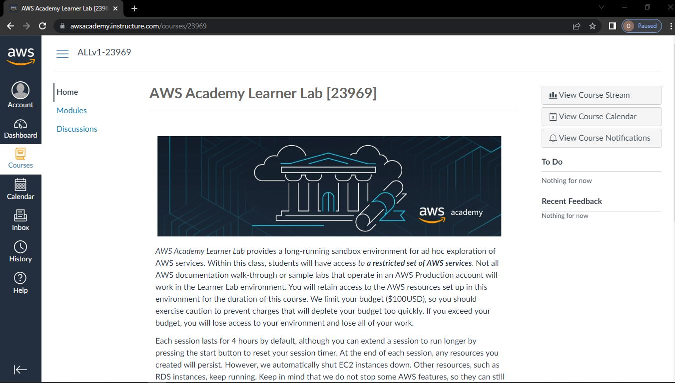

**Step-2: Click on module -> Select Learner Lab -> Click on AWS with indicated green light**

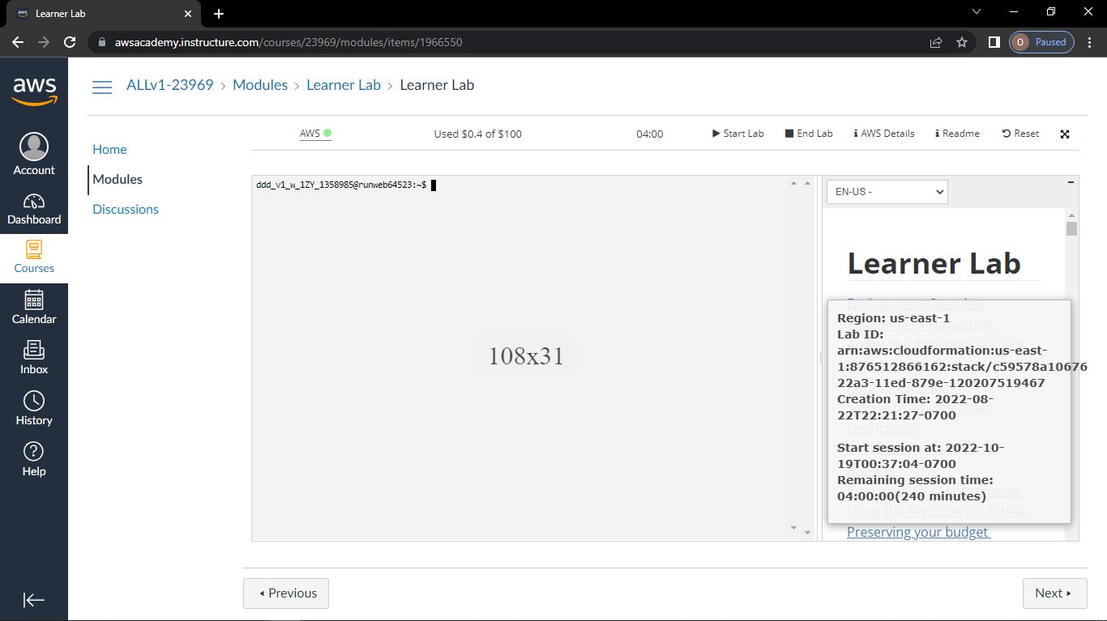

**Step-3: Go to Services -> Below that select Compute-> EC2**

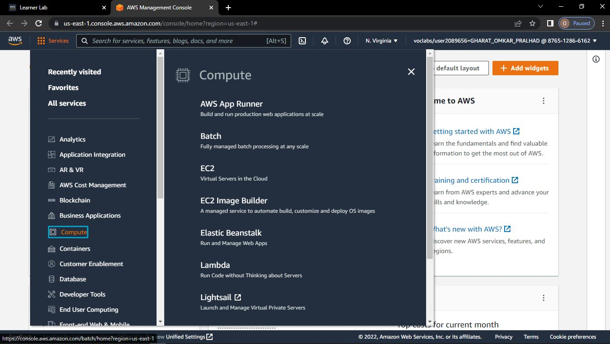

**Step-4: Click on EC2**

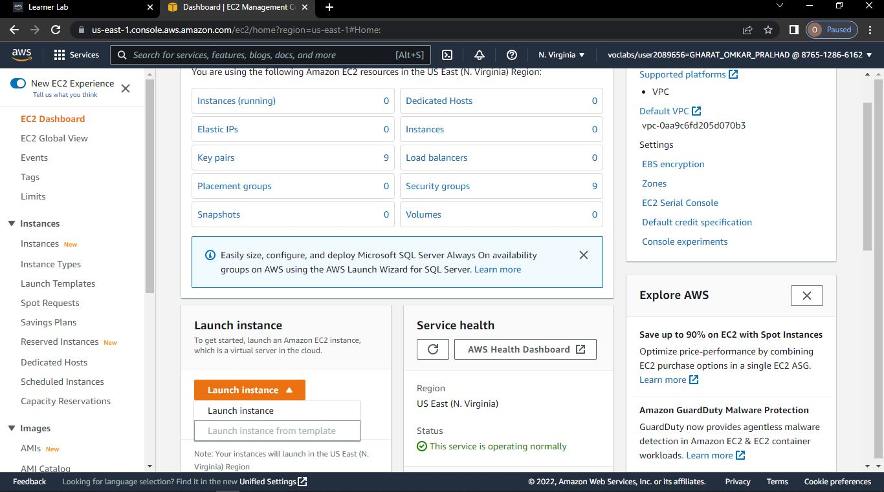

**Step-5: Click on launch instance**

**Step-6: Give any name of instance**

**Step-7: Give any name of key pair**

**Step-8: Click on create key pair**

**Step-9: Click on launch instance**

**Step-10: Click on view all instances**

**->Instance State will start Running**

**->Copy the IP address**

**Step-11: Go to Puttygen🡪Click on Load**

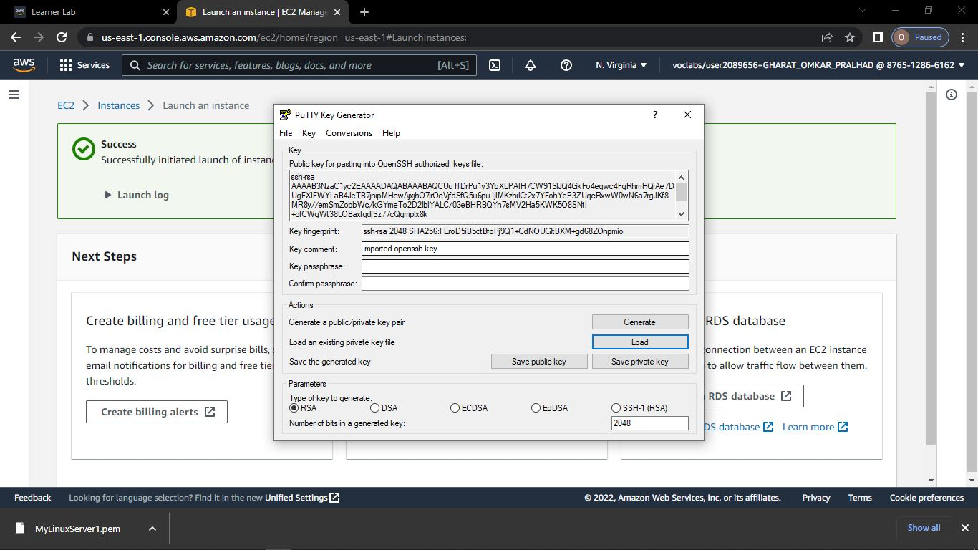

**Step-12: Open the pem file**

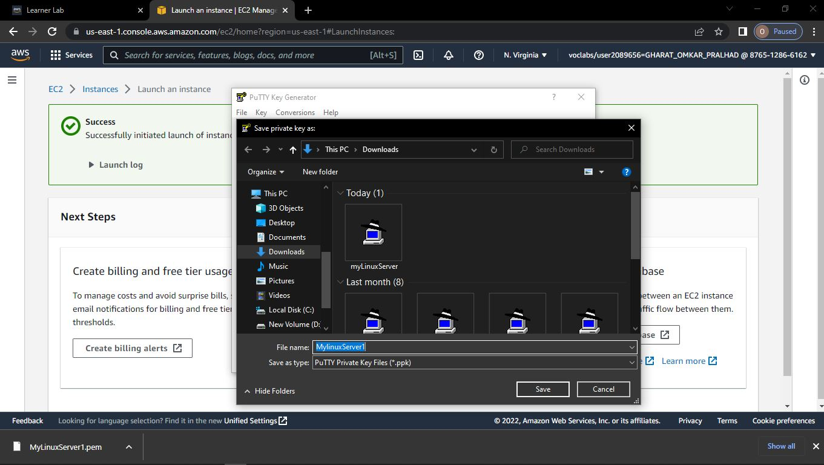

**Step-13: Click on Save Private Key**

**Give any name to the file🡪Click on Save**

**Open Putty 🡪Paste the IP address**

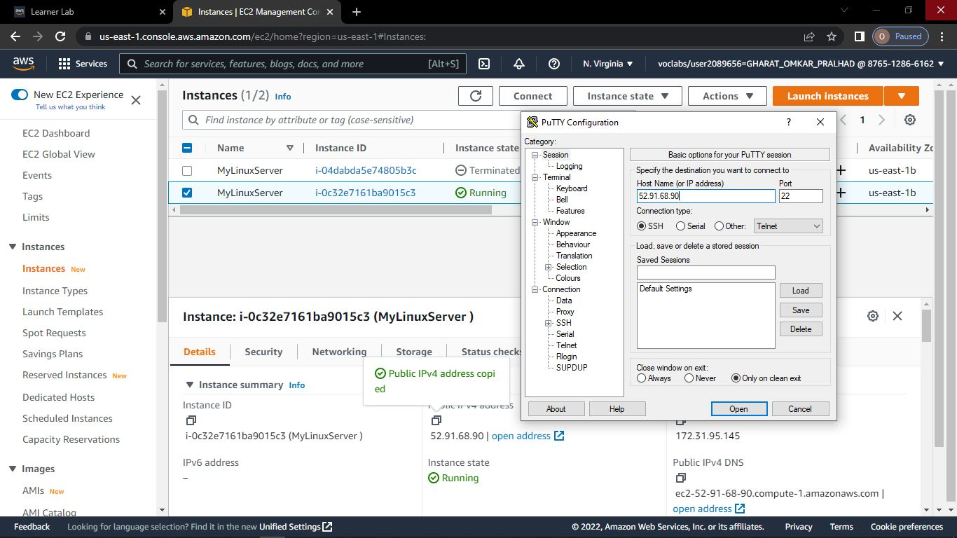



**Step-14: Go to SSH🡪Choose Auth**

**->Browse the newly created file**

**Step-15: Terminal will open Type the following commands.**

**->ec2-user**

**->sudo su**

**->yum update-y**

**->yum install httpd-y**

**->cd /var/www/html**

**->vi index.html**

**->service httpd start**

**->chkconfig httpd on**

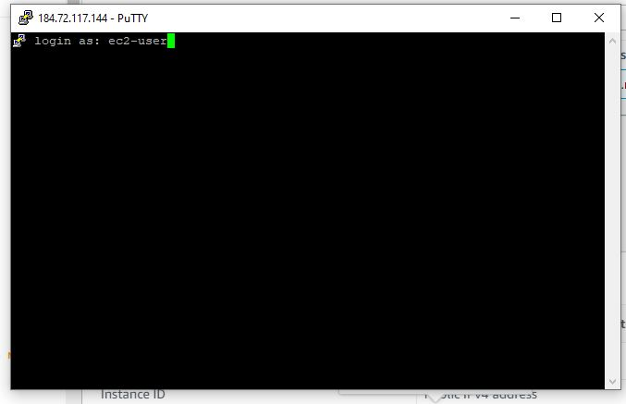

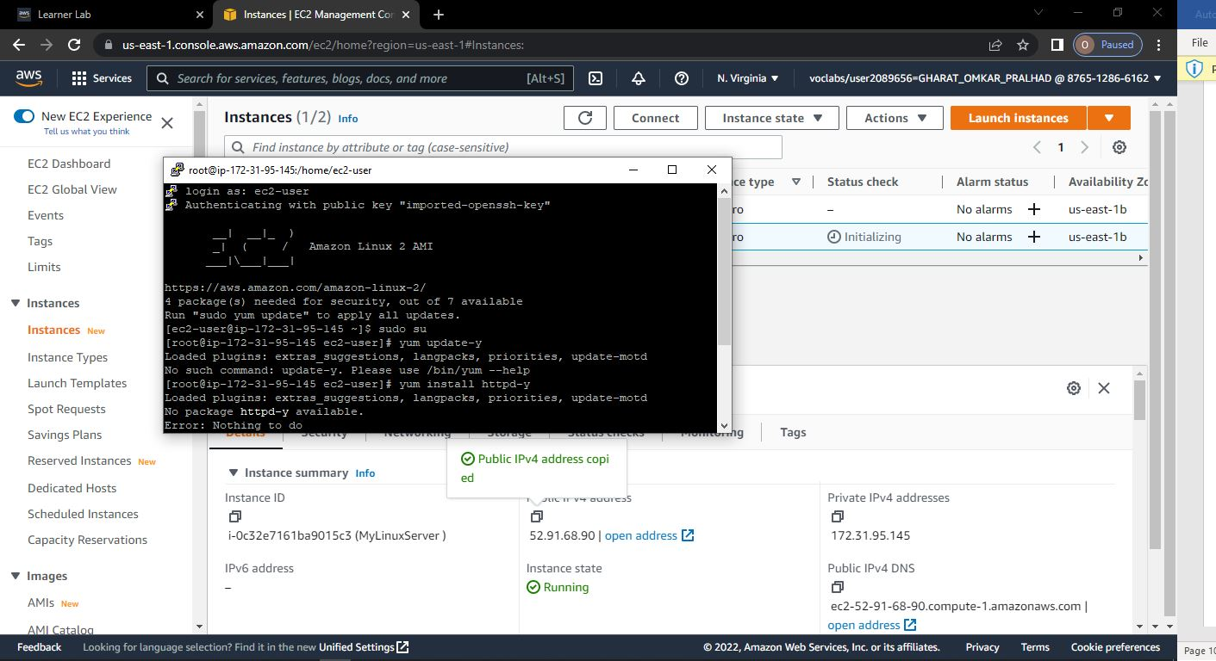

**Step-16: Open the browser and paste the IP address**

